CCHA Apparel Order Form

Traditional Grey Button Down (club will be purchasing for show, please record size)

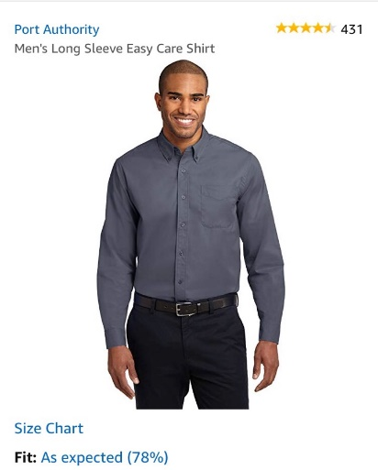
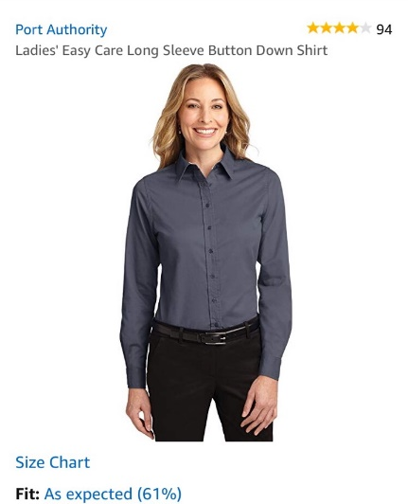

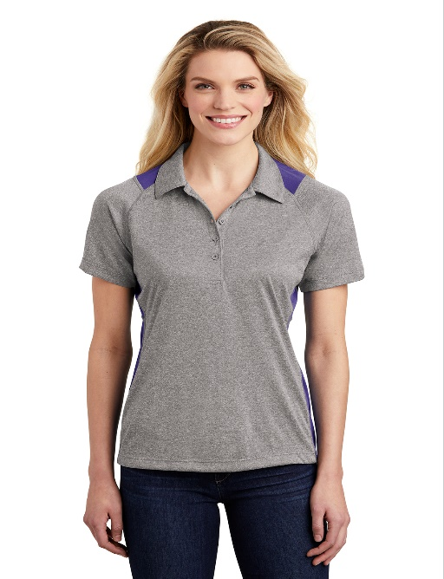
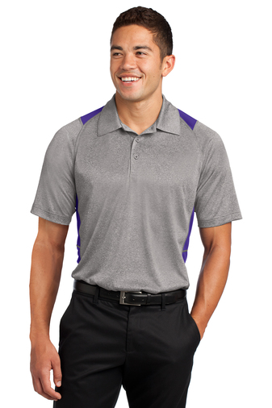

Polo’s: $25.00

Jackets: $45.00

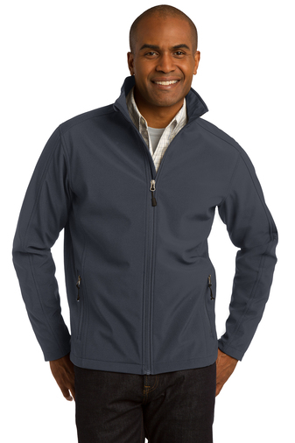
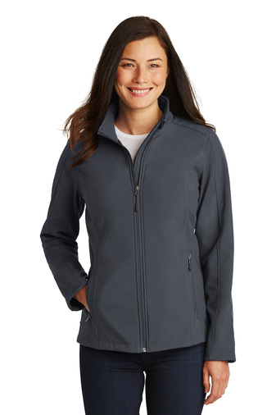

Vests: $28.00

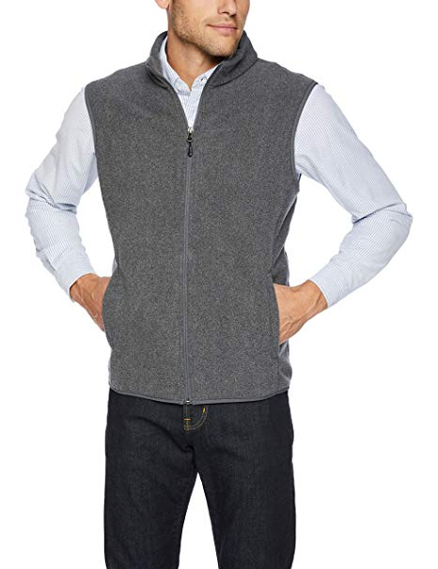
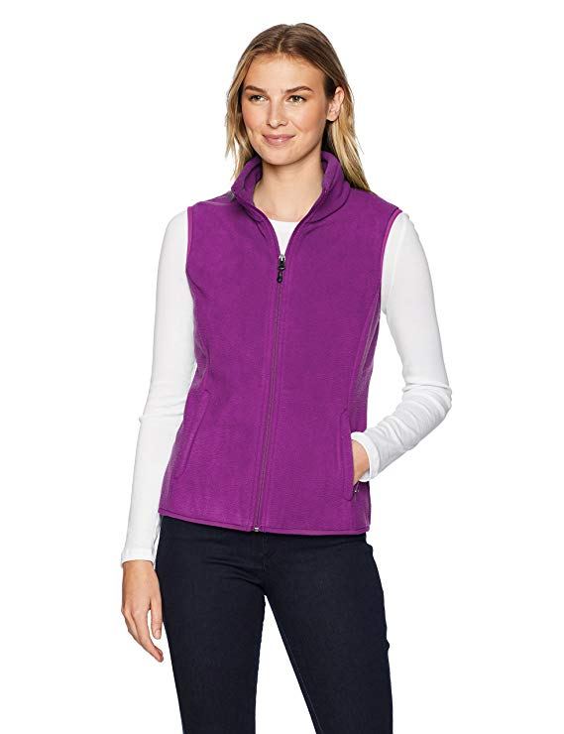

T-shirt (back being designed): Coming Soon!
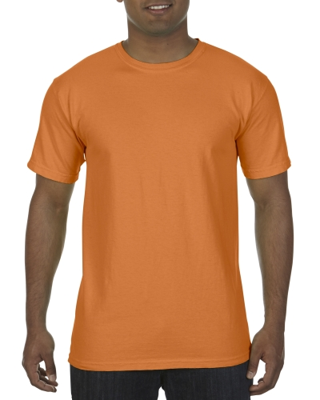

Hat: $14.00
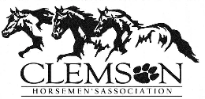
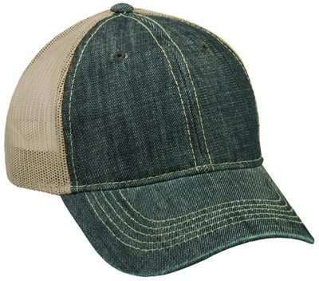

Order Form
Please return this to a CCHA executive no later than October 17th, 2018

Name: ________________________________________________________________________

Phone Number: ________________________________________________________________

Grey Button Down Shirt: FREE, need size so will have for TRTT show
Women’s:
Small ___ Medium ___ Large ___ XL ___ XXL ____
Men’s:
Small ___ Medium ___ Large ___ XL ___ XXL ____

Purple and Vintage Heather Polo’s: $25.00
Women’s:
XS___ Small ___ Medium ___ Large ___ XL ___ XXL ____ 3XL___ 4XL___
Men’s:
XS___ Small ___ Medium ___ Large ___ XL ___ XXL ____ 3XL___ 4XL___

Battleship Grey Softshell Jackets: $45.00
Women’s:
XS___ Small ___ Medium ___ Large ___ XL ___ XXL ____ 3XL___ 4XL___
Men’s:
XS___ Small ___ Medium ___ Large ___ XL ___ XXL ____ 3XL___ 4XL___

Women’s Purple vest & Men’s Grey Vest: $28.00
Women’s:
XS___ Small ___ Medium ___ Large ___ XL ___ XXL ____
Men’s:
XS___ Small ___ Medium ___ Large ___ XL ___ XXL ____

Burnt Orange Comfort Color T-Shirt: Coming Soon!
Small ___ Medium ___ Large ___ XL ___ XXL ____ 3XL___ 4XL___

Denim Hat: $14.00
One Size fits all ___

CCHA Exec. Only:
Total Cost: ______________________________ Cash ___ Check ___ CC___

